Dear Parents

The Food Standards Agency issued guidance last Friday stipulating that certain mustard products had been contaminated with peanuts. This guidance is still in place and work is ongoing to establish the extent of the contamination.

Upon receiving the warning, we took immediate steps to ensure the safety of your pupils. This included introducing a strict menu of safe whole foods for pupils with a peanut allergy; while our Vendor Assurance team carried out a full review of our supply chain to ascertain if any products were on the recall list and at risk.

Given that mustard, mustard powder and mustard flour are common ingredients, this remains a fast-moving situation and the Food Standards Agency’s investigation is still ongoing.

While this work continues, to provide choice and variety for your pupils with a peanut allergy, our specialist medical diet and culinary teams have amended our menu so that it is entirely free from mustard and safe for children with a peanut allergy to eat. This menu will be available from Monday 30 September 2024.

We take the management of allergens and the safety of every child we serve extremely seriously. We understand the disruption the Food Standards Agency warning has caused you, your pupils, and their parents, and we are very sorry for this. We will always do everything in our power to ensure that every child receives a safe, nutritious meal.

For further information, please visit the FSA website [**here.**](https://nam11.safelinks.protection.outlook.com/?url=https%3A%2F%2Fimpactfood.us6.list-manage.com%2Ftrack%2Fclick%3Fu%3D50fe9118f8bcb274d8ce305a0%26id%3D0a8d8a75c4%26e%3D97d5775efd&data=05%7C02%7Cgeoffrey.campion%40compass-group.co.uk%7C86136530c8024b1519c808dcdba03e7d%7Ccd62b7dd4b4844bd90e7e143a22c8ead%7C0%7C0%7C638626728503679954%7CUnknown%7CTWFpbGZsb3d8eyJWIjoiMC4wLjAwMDAiLCJQIjoiV2luMzIiLCJBTiI6Ik1haWwiLCJXVCI6Mn0%3D%7C0%7C%7C%7C&sdata=d12jx%2B%2BVujBYikPArMuSnDkIa%2BZpjKgOqqPVood%2FIGs%3D&reserved=0) If you would like to be made aware of future allergen alerts from the FSA, you can subscribe [**here.**](https://nam11.safelinks.protection.outlook.com/?url=https%3A%2F%2Fimpactfood.us6.list-manage.com%2Ftrack%2Fclick%3Fu%3D50fe9118f8bcb274d8ce305a0%26id%3D657e084525%26e%3D97d5775efd&data=05%7C02%7Cgeoffrey.campion%40compass-group.co.uk%7C86136530c8024b1519c808dcdba03e7d%7Ccd62b7dd4b4844bd90e7e143a22c8ead%7C0%7C0%7C638626728503693480%7CUnknown%7CTWFpbGZsb3d8eyJWIjoiMC4wLjAwMDAiLCJQIjoiV2luMzIiLCJBTiI6Ik1haWwiLCJXVCI6Mn0%3D%7C0%7C%7C%7C&sdata=VGU2M5JypcboY27haxaTBHSkiLKL5pR3VSODsA48UiQ%3D&reserved=0)

Yours sincerely,

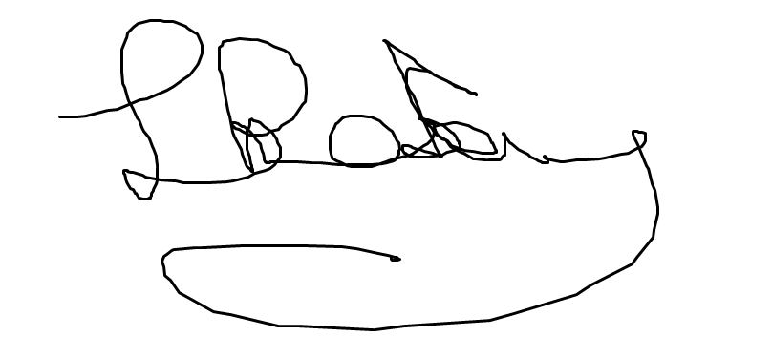

Lisa Priestley, Managing Director, Chartwells Schools